Project 2-1: Registration Form

Objectives
Use concepts from Chapter 1 & 2 to complete Project 2-1

Description
Create a program that allows a student to complete a registration form and displays a completion message that includes the user’s full name and a temporary password.

Requirements
- The expected output image provides the format for the program output.
- The user’s full name consists of the user’s first name, a space, and the user’s last name
- The temporary password consists of the user’s first name, and asterisk (*), and the user’s birth year
- Assume the user will enter valid data

Expected Output

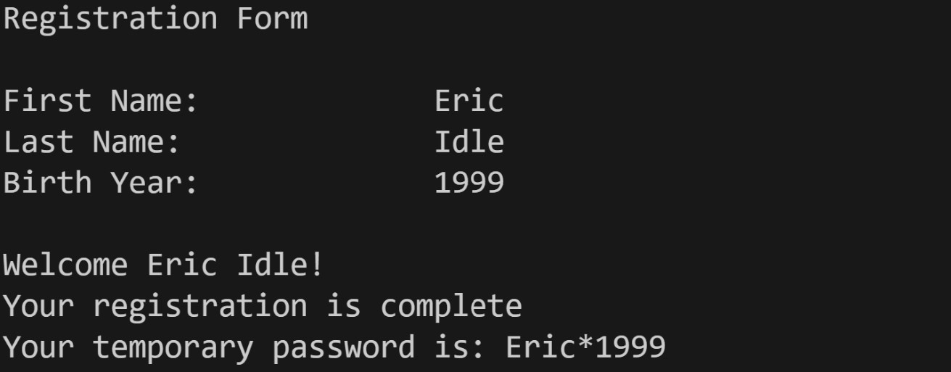

Grading Criteria
File naming convention | 5
Comments (Minimum file header comments and interior code) | 15
Use of input() function | 10
Use of F-String and/or string concatenation | 20
Descriptive variable names | 20
Output format | 30
Code does not compile | -50
Total | 100

